PARTNERSHIP FUND SPOTLIGHT
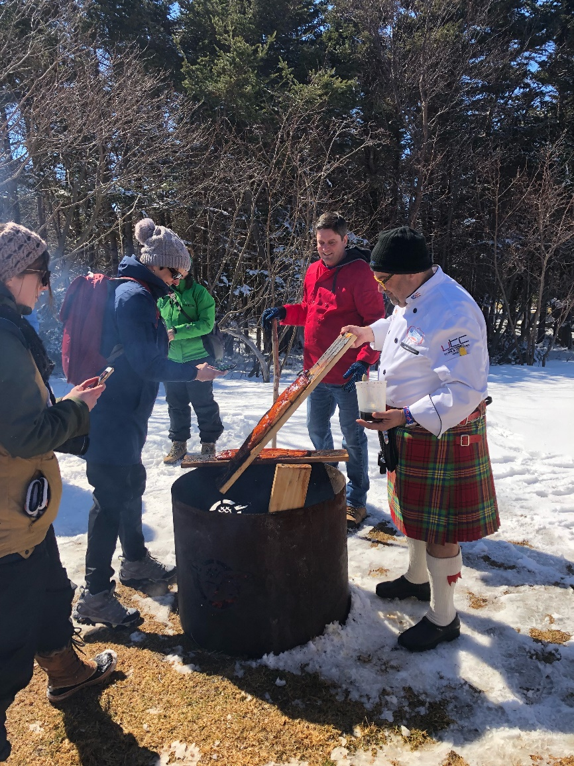
Project: Product Development Training – Edge of The Wedge
Partner Organization: The County of Prince Edward
Why did you apply for RTO 9 Partnership Funding?
The County is looking to focus on a combination of experiential tourism products and shoulder season attractions that will help to ‘manage’ Prince Edward County as a destination rather than simply market it as a destination. More recently, our focus has shifted to include destination development and experiential tourism. Receiving funding through RTO 9 has allowed two staff members from the Community Development Department, specifically, Museums and Destination Marketing departments to attend GMIST’s Edge of The Wedge and deep dive into the development process of experiential tourism. As a result, experiential tourism is now a key pillar of our work, and the intent is to continue in this direction to create memorable experiences for visitors while developing sustainable, shoulder-season specific products that will support year-round visitation.

How will attending Edge of The Wedge help The County’s tourism operators?

In building experiential tourism knowledge within the department, we are using that knowledge to champion the concept of ‘experiential tourism’ within the community to local businesses and stakeholders, and to implement into our own programming. We looked to help identify which businesses might be ready, and the right fit for the experiential tourism program (2019/20 and beyond);
In the short-term, as a result of attending Edge of The Wedge, we’ve partnered with Bay of Quinte Tourism to provide operators with immersive, hands on experiential tourism training with the goal of being market-ready within 6 months. In the long-term, we have plans to develop a regional approach to experiential tourism training for regional operators in partnership with Bay of Quinte Marketing and Hastings County.

Did you meet your goals and objectives in attending Edge of The Wedge?
In a nutshell, yes. A broad foundation of experiential tourism knowledge now exists within the department and methodology is top of mind when creating workplans, new projects, and improving existing projects. 6 local businesses were identified as a great fit to begin offering shoulder-season experiences and were selected to attend the immersive training course later in the year in partnership with Bay of Quinte and are meant to be market-ready with new products in early 2020. The Museums of Prince Edward County hosted roughly 8 events using applied experiential tourism methodology.
Overall thoughts on your time spent at Edge of The Wedge?
Edge of the Wedge was a wonderful experience that really got us thinking about tourism and visitors in a very different way. If the opportunity was to present itself to others, I’d highly encourage anyone working in the tourism industry –operators and enablers – to go to the edge.

